More sustainable barbecues

Now that it’s summer, many of us will be getting together outdoors for a barbecue.
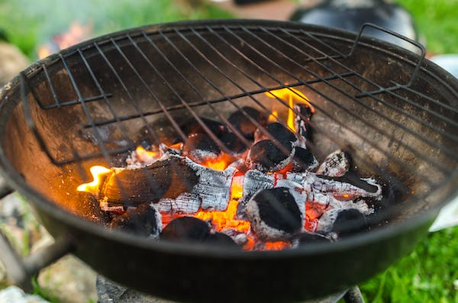
Here are some tips for a more sustainable barbecue that is also better for your health:

Type of BBQ
- Steer clear of throwaway BBQs and disposable plates/utensils. Disposable BBQs have also been linked to some of the more serious UK wildfires.
- Grills using natural gas or electricity are generally considered much more environmentally friendly and it has been estimated that their carbon footprint is one third of a charcoal one.
- If this isn’t possible, go for an egg-shaped, ceramic Kamado-style BBQ as it needs less charcoal because its shape helps maintain higher levels of heat. This also means it uses less fuel.

Fuel and lighters
- If you use charcoal, choose sustainably sourced charcoal which isn’t linked to mass deforestation in developing countries. Alternatively, try other green options such as coconut shell, bamboo or briquettes made from agricultural waste and clay.
- Conventional charcoal bricks are comprised of wood by-products, sawdust, and lighter fluid. These bricks often release volatile compounds (VOCs) into the atmosphere as they burn, which can be inhaled and also contaminate your food (5).
- Use wood-based firelighters and avoid petroleum-based lighter fluids and self-lighting charcoal.

Cooking
- Avoid pre-packaged meat and buy meat or fish from local, sustainable producers (pasture/grass fed) instead
- Trim the fat off meat – this reduces the amount of smoke (and VOCs) produced
- For an even healthier BBQ, try some vegetarian or even vegan options: (https://www.bbcgoodfood.com/recipes/collection/vegetarian-barbecue-recipes)
- Plan your cooking times in advance so that you only pre-heat the grill for as long as needed

After the BBQ
Finally, clean out your grill while it is still hot when you’ve finished cooking. A build-up of grease and food particles in your grill will produce unnecessary smoke (and VOCs). Use a mixture of water and baking soda to clean off the cooking grates and don’t forget to clean out grease drip trays under your grill.

For a good overview and more tips, see https://www.countryandtownhouse.com/food-and-drink/sustainable-barbecue-guide/ and https://eco-age.com/resources/bbq-season-sustainably/

