The hidden impact of engine idling – why it’s better to switch off!

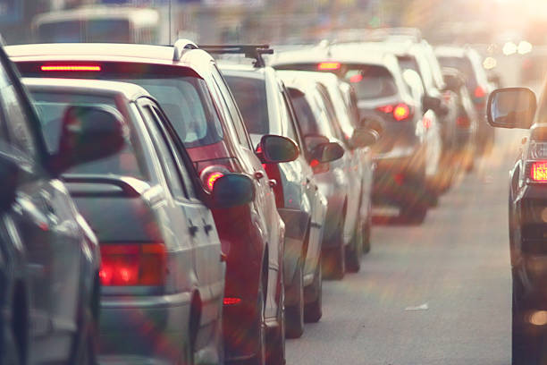
Did you know?
- When your engine is idling, you are not just wasting fuel, you are breaking the law and may face a fine (1)?
What is engine idling?
Idling is the act of leaving a vehicle’s engine running unnecessarily. For example, if you’re stationary or parked with the engine running, this would be classified as idling.
It’s easily done if you are waiting in your car to collect someone, checking your phone, or making a call. But if you do have your engine idling, you could face a fine upwards of £20, or £80 in areas of London – as per the Road Traffic (Vehicle Emissions) Regulations of 2002.
Why is engine idling so damaging?
It may not even occur to many of us that there is any problem with sitting in our car with the engine running, but here are some disturbing facts about why it’s better to switch off:
- Idling your engine for more than 10 seconds uses more fuel and produces more emissions than stopping and restarting your engine (2).
- An idling car can produce up to twice as many exhaust emissions as a moving one and can fill up to 150 balloons with harmful emissions every minute (3).
- One minute of engine idling produces more carbon monoxide than the smoke from 3 packets of cigarettes (4) (that’s the equivalent of one cigarette per second).
- People inside cars with idling engines are exposed to high levels of air pollution, with children especially at risk of harmful effects. As well as carbon dioxide, idling engines churn out nitrogen oxide, sulphur dioxide, hydrocarbons and particulate matter, all of which contribute to poor air quality. Recent research has shown that drivers waiting at traffic lights were exposed to up to 29 times more harmful pollution particles than those driving in free flowing traffic (5,6).
Poor air quality and the impact on health
Air pollution is the largest environmental health risk we face today. It has been linked to cancer, asthma, stroke and heart disease, diabetes, obesity and dementia either as a cause or as a complicating factor contributing to premature death.

London has 4,000 deaths per year that are attributable to air pollution (7) and those with pre-existing conditions and young children are particularly badly affected
But aren’t there good reasons for not switching car engines off and on again?
The following reasons are often given (incorrectly) by people for leaving their car engine idling:

1) Leaving your car running when stationary for a short time is cheaper than turning it off and on again
It is actually cheaper to turn off your engine. Between 5% and 8% of fuel use occurs while your engine is idling. It’s a common misconception that stopping and starting the engine uses up more fuel than leaving the car running so, by switching off, you’re also cutting down on fuel costs (8).

2) Keeping your engine running is better for your car than switching off and on again
Leaving your engine idling isn’t just bad for the environment, it can be bad for your car too. This is because when your car is stationary, it’s not operating as efficiently as it should and this leaves a fuel residue, which can damage important components such as engine cylinders, spark plugs, and the exhaust system. This in turn can increase fuel consumption by up to 5% (9).

(The RAC advises that frequent restarting has little impact on the battery although older vehicles (around eight years old) and vehicles with older batteries (around five years old) may struggle if started too often in a short space of time.)

3) You need to keep the engine running to keep the heater on
If you park and need to keep the heater on, rather than turning the car off completely, just turn off the engine. The heater should stay warm for up to 30 minutes.

What else can I do?
Try to consider how long you are going to be stationary in traffic. The RAC recommends that motorists turn off their engines if they don’t think they’ll move for around two minutes. It may feel as though it won’t make much of a difference but switching off your engine can go a long way to improving air quality.

Poor air quality affects everyone, but especially children – remember, it’s better to switch off! (10)

References:
- https://www.rac.co.uk/drive/advice/emissions/idling/
- https://www.motorbiscuit.com/idling-a-car-engine-10-seconds-uses-more-fuel-stopping-restarting/
- https://www.richmond.gov.uk/services/environment/pollution/air_pollution/engine_idling
- http://enginesoff.com/pdfs/CASEO-Background-Report.pdf
- https://www.surrey.ac.uk/news/latest-research-reveals-sitting-traffic-jams-officially-bad-you
- https://www.rac.co.uk/drive/news/motoring-news/in-car-pollution-equivalent-to-passively-smoking/
- https://www.london.gov.uk/city-hall-blog/clean-air-day-2022-action-reducing-londons-pollution-cannot-wait
- https://www.cornwall.gov.uk/environment/environmental-protection/air-quality/vehicle-idling/
- https://www.bewiser.co.uk/wiser-blog/eco-friendly-driving/how-does-idling-your-engine-affect-your-car-environment-and-your
- https://www.oxford.gov.uk/info/20299/air_quality_projects/1258/anti-idling_air_quality_campaign/3

