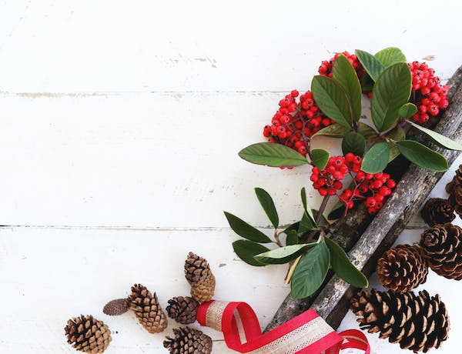
Dreaming of a greener Christmas…

There are some truly worrying statistics around the impact of Christmas on the environment:

In the UK alone, nearly one fifth of children’s gifts are unused, exchanged or thrown away, resulting in around £760 million of Christmas presents going to waste each year (1)

It’s estimated that 1 billion Christmas cards are binned by UK households each year (equivalent to 33 million trees. Around 114,000 tonnes (equivalent to 650,000 reindeer!) of plastic packaging goes to landfill and a typical household generates over three black bags of packaging each Christmas. (2)

The amount of wrapping paper thrown away in the UK alone would stretch from earth to the moon and we chuck out enough tin foil to cover Suffolk (3)

10 million turkeys are bred and slaughtered in the UK every Christmas (4) and 2 million turkeys, 5 million Christmas puddings and 74 million mince pies are thrown away while still edible, resulting in almost 270,000 tons of food waste (5). We all pay for this to be disposed of through our council tax bills.

Here are some tips for anyone who wants to make their Christmas more sustainable this year (and save money too):

Presents:
- A smaller number of good quality presents from sustainable manufacturers are better than lots of cheap items that will not be appreciated for long and are often plastic and/or easily broken.
- Try to shop locally from small businesses – this supports them and reduces travel/delivery related emissions.
- Many very small children or toddlers enjoy the excitement of unwrapping more than the present, so instead of a cheap (plastic) toy, you could wrap functional things that you would use with them anyway, such as clothes, books or crayons.
- Consider "adopting” a child/endangered animal via a charity for a year as an alternative Christmas present, particularly for someone who is difficult to buy for, or check out the Good Gifts website (https://www.goodgifts.org/) which sells gifts that make a positive difference.

Christmas cards, wrapping and decorations:
- If you are using wrapping paper, choose 100% recyclable (and avoid shiny/sparkly paper which is not). If possible, choose wrapping paper made from recycled paper.
- Reuse any present bags/boxes or wrapping paper you kept from last Christmas or try furoshiki – the art of Japanese scarf wrapping. You simply tie up a gift in a square of pretty fabric and the wrapping can be used again and again.
- Choose charity wrapping paper and Christmas cards rather than shop-bought cards (as even if they donate to a charity, it will only be a small proportion of what you pay).
- Alternatively, you could just use a roll of brown paper tied with a coloured ribbon (which can be reused multiple times).
- Save last year’s Christmas cards and cut them up to make gift tags for this year.
- Avoid glittery decorations as plastic-based glitter is a source of microplastic pollution. Whilst Tinsel is also plastic based, it can be reused and doesn’t shed, so is more environmentally friendly.

There are countless sites with ideas for making decorations from recycled materials (see below) which is not only sustainable, but fun to do with your children or grandchildren.

Food:
Many people go completely overboard with food at Christmas. Remember that there is a limit to how much people can eat in one day, so plan meals over the festive period. Overeating isn’t great for your health or your wallet!

Vegetarian and vegan options such as nut roasts are not only a more sustainable option, but can often be cheaper, healthier and just as satisfying as turkey.

Love your leftovers - there are some great recipes including soups and curries which can be frozen and keep you in packed lunches well into January.

1. https://www.scottishfinancialnews.com/articles/st-james-s-place-nearly-760m-wasted-each-year-on-unwanted-christmas-presents
2. https://www.gwp.co.uk/guides/christmas-packaging-facts/#card
3. https://www.gov.uk/government/news/dont-increase-your-christmas-waste-line
4. https://www.ecoandbeyond.co/articles/christmas-food-waste/#:~:text=In%20the%20UK%20we%20waste,tonnes%20of%20food%20each%20year.
5. https://metro.co.uk/2018/12/06/eat-turkey-christmas-many-eaten-year-8215965/
6. https://greenglobaltravel.com/recycled-christmas-decorations-diy-christmas-crafts/
7. https://moralfibres.co.uk/zero-waste-christmas-decorations-to-diy/
8. https://www.pinterest.co.uk/wastemanagement/recycled-ornaments/

